Assignment 1
Date Assigned: 09/08/2017
Due: Midnight 09/21/2017 on iLearn

Please read turn-in checklist at the end of this document before you start doing exercises.
Section 1: Pen-and-paper Exercises
- Arrange the following functions in ascending order of growth rate (15 points):
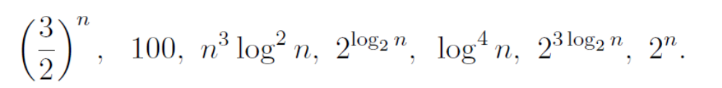
You are NOT required to justify your ordering.
Note:
In this problem, you are asked to identify if f1(n) < f2(n) for a “sufficiently large” input size n. However, for small values of n this is not always true.

- Analyze the following code and provide a "Big-O" estimate of its running time in terms of n. Explain your analysis. 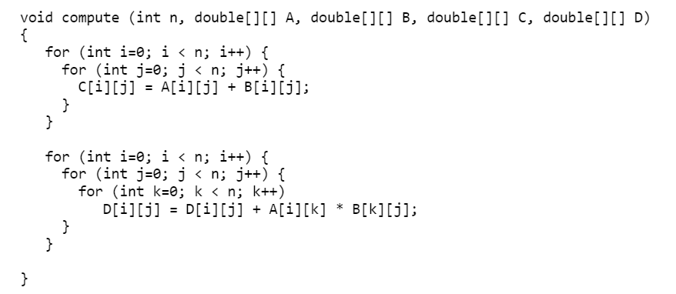
Note: Credit will not be given only for answers - show all your work:
(10 points) steps you took to get your answer.
(5 points) your answer.

- Consider the following problem:

Input: an array, A, of n sorted integers (positive, negative, or 0) that
A[0] <= A[1] <= A[2] <=…A[n-2] <= A[n-1]

Output: re-arrange elements in A such that:
Element at even position (i.e., A[0], A[2]) are less than or equal to both of its neighbors
Element at odd position (i.e., A[1], A[3]) are greater than or equal to both of its neighbors

A[0] <= A[1] >= A[2] <= A[3] >= A[4] <= A[5]…

Design an algorithm that solves this problem in O(n) time.

When analyzing the running time, you should follow the RAM model discussed in class.
Hint: when showing that the running time is O(n), reviewing lecture notes.

Important: In all of the assignments of this course, when you are asked to give an
algorithm for a problem, you are (unless otherwise indicated) expected to
(i) describe the idea behind your algorithm in English (10 points);
(ii) provide pseudocode (10 points);
(iii) analyze its running time (10 points).
Regarding requirement (iii): Unless otherwise specified, show the steps of your analysis
and present your result using big-O.

- Consider the following problem:
Input: An array of integers
Output: You need to rearrange the array to have the following property:
- Suppose the first element in the original array has the value x.
- In the new array, suppose that x is in position i, that is data[i] = x. Then, data[j] <= x for all j < i and data[j] > x for all j > i. Thus, informally, all the values to the "left" of x are less than (or equal to) x and all values to the right are larger than x.
- Here's an example. Suppose the array has the elements in this initial order: 4,3,9,2,7,6,5. After applying your algorithm, you should get: 3,2,4,5,9,7,6. That is, the leftmost element, 4, is positioned in the resulting array so that all elements less than 4 (that is, 2, 3) are to its left (in no particular order), and all elements larger than 4 are to its right (again, in no particular order).

Design an algorithm that solves this problem in O(n) time.

Section 2: Java Implementation
- Implement problem 3 in Java.
Note:
Find a file called Problem3.java in assignment 1 folder.
Complete the method of checksum().
Test your method in the main method provided following the comments.

Important: In all of the assignments of this course, when you are asked to implement an
algorithm for a problem, your code will be evaluated based on:

5 points - Execution
Each file must run without error or warning on valid input described in the main method provided.

5 points - Within Code Documentation
Is the code documented for obvious understanding of the use, preconditions, and postconditions of each function?

20 points - Correctness
Is the algorithm implemented correctly? Does your method pass the test?

- Implement problem 4 in Java.
Note:
Find a file called Problem4.java in assignment 1 folder.
Complete the method of partition().
Test your method in the main method provided following the comments.

TURN-IN CHECKLIST:

- Answers to Section 1 (.doc/.txt/.pdf), and to Section 2 (all your source Code (.java files)). Remember to include your name, the date, and the course number in comments near the beginning of your code/report.

- Create a folder and name it 'FirstName_LastName_assignment_1'. In the newly created folder copy and paste your files (.doc/.txt/.java files). Then compress the folder, and push it to iLearn.

